Rebekah Johnson Portfolio Outline

# Homepage

Name: Rebekah Johnson

School: Harrisburg Area Community College (HACC)

Major: Web Development & Design AAS

My passion lies in applying my creative skills to improve any project I am working on. I enjoy working with others to make the clients visions for a project a reality.

Navigation: Nav bar at top with these categories. 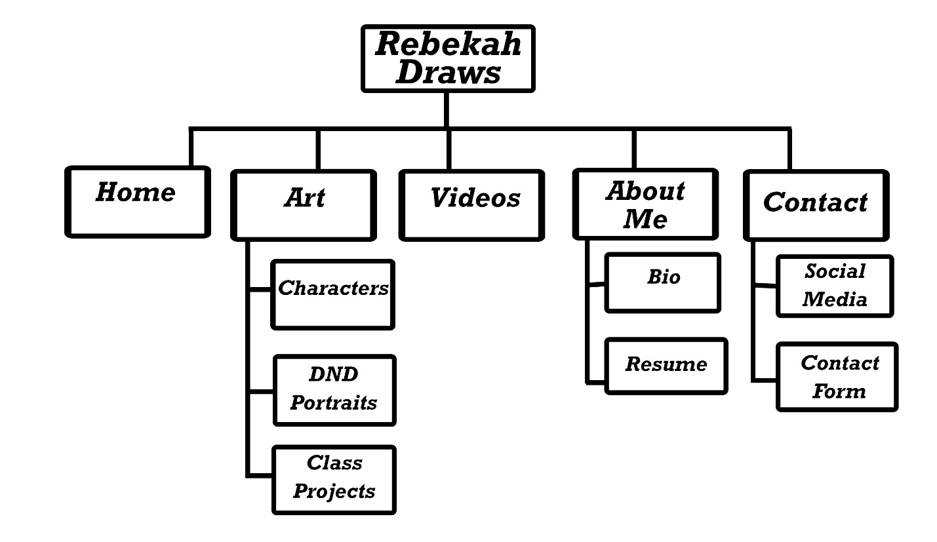

# About Me

I am a student at HACC and will graduate at the end of the 2021-2022 school year with a degree in Web development and design. I live in New Oxford, PA and have lived there since 2008. In my previous work experience, I have worked in a supervisor position at Sheetz and was appreciated by all my coworkers for my great work ethic and respect for others. At HACC, I gained experience with Adobe Creative Cloud products, JavaScript, C#, and many other programs and languages. I have some experience in acting and livestreaming, and I am social media literate. My hobbies include drawing and TTRPGs, and I like to combine the two.

Contact information to include: Email and Phone#. Possibly links to social medias and LinkedIn page.

# Selected Works

Projects from previous classes (approximately 10 or so)

Personal Character designs (about three)

Video from previous class, maybe one or two of my own

Reach out to a local business and offer to make a new website (Possibly at the markets, maybe An Early Elegance)

# (Insert PDF here)

# Other

I can work on getting a quote from my boss.

Programming languages: C#, Javascript, HTML5/CSS

Web tech experience: SQL, jQuery, Visual Studio, Adobe Dreamweaver, notepad++

Other program experience: Adobe Creative Cloud products, Microsoft Office products (Word, Access, Excell), Inkscape, Twitch Studio

Personal tools: Samson Q2U Microphone, Logitech C922 Pro Stream Webcam, green/blue screen, Huion drawing tablet, personal-built PC (AMD Radeon RX 5700 XT, AMD Ryzen 5 3600 6-Core Processor, 16 GB Ram)

In my personal time, I have dabbled in live-streaming, video production, and acting (live and voice). I have experience with zoom, and other forms of communication. Navigating a new platform tends to be easy for me.